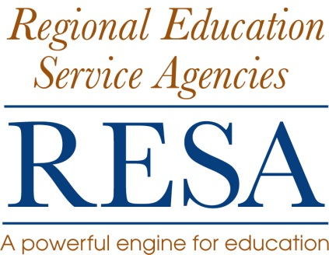
Position Title: School Support Specialist
Location: RESA 4
Salary: RESA 4 Salary Schedule
Contract: All RESA 4 employment agreements are for one year or less. RESA does not issue continuing employment agreements. The agreement for this position is 240 day employment term for FY 2015. The execution of this agreement is contingent upon funding. All RESA 4 personnel are will and pleasure employees of the West Virginia Board of Education.
Job Description:
The employee will:
- coordinate RESA education activities, programs and services, and
- work collaboratively to address the needs of schools and school systems..

Position Qualifications:
- Teaching Certification in Education
- Masters Degree in education
- Administrative certification and experience (preferred)
- Minimum of five years of teaching experience (preferred)
- Demonstrated experience and knowledge of education programs and initiatives and integration of them with other state, local and federal initiatives
- Knowledge of local, state, and federal education policy and law
- Strong oral and written communication skills
- Ability to schedule, organize, and perform multiple assignments
- Knowledge and expertise in highly effective research-based instructional practices
- Demonstrated knowledge and experience in
  - integrating positive behavior support programs,
  - supporting effective school leadership research and practice,
  - integrating technology into classroom instruction,
  - developing and delivering professional development,
  - supporting and facilitating professional learning communities,
  - managing State and federal program budgets and
  - writing and managing grants.

Position Responsibilities:
- Maintain professional work habits
- Work with principals and teachers in building capacity to address identified instructional needs for their respective schools
- Work with schools in integrating technology in classroom instruction
- Provide guidance and assistance in building effective learning communities within schools
- Work with central office personnel (curriculum and instruction supervisors, superintendents, assistant superintendents, and principals) to identify and address specific needs of the district, and individual schools within the district
- Work with counties and schools to develop and implement performance assessments in the context of assessments of and for learning
- Work with individual county curriculum and instruction supervisors in implementing county school system programs
- Work with schools and school districts to facilitate and provide professional development to meet specific needs and requests
- Provide feedback regarding program progress and compliance to the Regional Council
- Perform other duties as assigned by the Executive Director

Reports To: RESA 4 Director

Application: Send a letter of application, resume, and the names of three
References with phone numbers and e-mail addresses to:

David A. Warvel, Executive Director
RESA 4
Old Main Drive
Summersville, WV 26651

Application Deadline: Friday, September 12, 2014

Equal Employment Opportunity: “Equal employment opportunity will be granted to all persons regardless of age, race, creed, national origin, or handicap and no discrimination based upon such factors will be made in salary, promotion, demotion, transfer or termination of any employee”

